Brief description of ideas for "TRIANGLES" task solving.

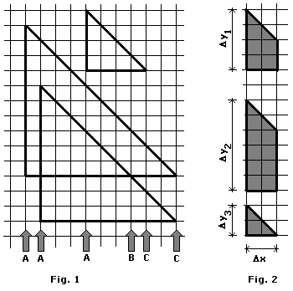

We can use a plane sweep method sweeping from left to right. There are three kinds of event points for the algorithm (denoted in Figure 1 by gray arrows) :
- beginning of new triangle (value x_{i} from description);
- crossing point of one triangle horizontal edge with others hypothenuse;
- rightmost vertex of some triangle (value x_{i}+m_{i} from task description).

If we look at these event points consecutively, we can calculate common area increasing, if we at each event point x_{k} know number n_{k} of actual line segments and sum of their lengths $s_{k}=\sum_{i}{{Δy}_{i}}$, where Δy_{i} is length of one segment. Example with three segments are shown in Figure 2.

Then increment for each gap between two neighbour event points (Δx = x_{k+1} - x_{k}) can be calculated as $s_{k}Δx−n_{k}\frac{(Δx)^{2}}{2}$. Performing sweeping from left to right and summing up these increments we finaly obtain total common area of all triangles.

